}

Guide 1. APT Project Definition
Capstone Course

- PART I
1. Personal Information
The following table must be completed with the requested information.

Student name | Pablo Maximiliano Báez Godoy
National ID (RUT) | 19.501.732-8
Program | Computer Engineering
Campus | VESPUCIO

2. APT Project Description
In the description, briefly state the name of your APT project and the graduate profile competencies that you will put into practice. If your program has defined areas of professional performance, also mention the areas to which the project is linked.

Project name | LicitaWatch
Area(s) of professional performance | 1) Software project design, management, and quality: Requirements Design and Management, Software Engineering, Software Quality, Project Evaluation, IT Project Management, and Risk Management. 2) Programming and business intelligence: Algorithm Programming, Web Programming, BPM, and Business Intelligence. 3) Data modeling, architecture, and security: Database Modeling, Database Querying and Programming, Architecture, Platform Integration, and Computer Systems Security. As LicitaWatch is a microservices platform involving data management, distributed architecture, security, and a subscription-based business model, it is linked to the three training areas indicated above.
Competencies | Specialty competencies: 1. Manage the configuration of environments, application services, and databases in an enterprise environment in order to enable operations or ensure the continuity of systems that support business processes, in accordance with industry-defined standards. 2. Provide IT solution proposals by comprehensively analyzing processes according to the organization’s requirements. 3. Develop a software solution using techniques that systematize the development and maintenance process, ensuring achievement of objectives. 4. Build data models to support the organization’s requirements according to a defined design that is scalable over time. 5. Program queries or routines to manipulate information in a database according to the organization’s requirements. 6. Perform certification testing of both products and processes using industry-defined best practices. 7. Build the architectural model of a system solution that supports business processes according to the organization’s requirements and industry standards. 13. Build programs and routines of varying complexity to address organizational requirements, using current market technologies and good coding practices. 14. Implement comprehensive system solutions to automate or optimize business processes according to the organization’s needs. 15. Address system vulnerabilities to ensure that the software developed complies with industry-required security standards. 16. Manage IT projects, providing alternatives for decision-making according to the organization’s requirements. Generic competencies: 12. Ability to generate innovative ideas, solutions, or processes that respond to productive or social opportunities, needs, and demands, collaborating with others and assuming calculated risks. 19. Develop entrepreneurial projects by identifying opportunities within the specialty, applying techniques aligned with the objective and focusing on adding value to the environment.

3. APT Project Rationale
The following fields must be completed with the requested information. This section is intended for you to describe your project in detail and justify its relevance and alignment.

Relevance of the APT Project | LicitaWatch seeks to address the lack of a dedicated, traceable, and controlled channel for managing private tenders. Currently, companies in any industry that need to purchase or contract works, services, or supplies rely on spreadsheets, email, or generic portals, without a dedicated channel to publish tenders and receive applicants; at the same time, suppliers (applicants) do not have a centralized and reliable place to search, compare, and apply for private tenders, causing them to miss business opportunities due to the absence of a common channel. This issue is relevant to the professional field of Computer Engineering because solving it requires designing and implementing a complete software platform (microservices architecture, data modeling, authentication and security, payment gateway integration, and an artificial intelligence assistant), thereby comprehensively applying competencies specific to the discipline. The project is situated in Chile, specifically Santiago, and is aimed at companies from any industry, without being limited to a specific municipality, institution, or sector. The project’s value proposition is to provide a private, proprietary, and self-sustaining platform (funded through Standard and Premium subscription plans managed by the MS-Sales microservice) that does not depend on external public procurement portals, benefiting both companies that publish tenders and clients/suppliers that apply for them.
APT Project Description | The LicitaWatch project consists of the design and development of a private web platform for tender management, aimed at centralizing and digitizing the interaction between companies that need to contract products or services and SMEs interested in participating in those opportunities. The platform will allow tendering companies to publish and manage tenders, while SMEs will be able to search, filter, review requirements, and submit their applications within the same system. These functionalities make up the functional core defined for the project. The solution will include three main profiles: Tenderer, SME, and Administrator, implementing authentication and authorization through JWT and role-based access control (RBAC). It will also include tender and application management, subscription plans, sales, payment gateway integration, notifications, and a panel for the platform’s general administration. As an innovation component, LicitAsist will be incorporated: an artificial intelligence-based conversational assistant that will use information available on the platform to support users in tasks such as understanding requirements, improving the wording of tenders and applications, summarizing information, and consulting available opportunities.
Alignment of the Project with the Graduate Profile | The LicitaWatch project is directly aligned with the graduate profile because it enables the integrated application of competencies associated with the design, development, implementation, and deployment of IT solutions aimed at addressing organizational needs. In this case, the project addresses the need to centralize and digitize the processes of publishing, searching, managing, and applying for private tenders through a software solution. Its development will require requirements gathering and analysis, software architecture design, database modeling and management, Front End and Back End development, construction and integration of REST APIs, implementation of authentication and authorization mechanisms, software testing, and solution deployment. These activities are directly related to the professional performance areas defined for the program, particularly Requirements Gathering, Databases, Front End Development, Back End Development, Full Stack Development, Software Quality, and Project Management.
Relationship with Professional Interests | LicitaWatch is directly related to my professional interests, as it allows me to go deeper into Back End development and microservices architecture, areas in which I seek to specialize and build my career. As the person in charge of developing the system's APIs (Users, Tenders, MS-Sales, Notifications and Assistant) and supporting DevOps tasks, I will be able to strengthen my knowledge of Spring Boot, REST API design, security through JWT and RBAC, and integration with external services such as payment gateways. In addition, the incorporation of LicitAsist allows me to explore the integration of artificial intelligence into software solutions, a field of growing demand in the industry that I am interested in developing. Finally, the subscription-based business model aligns with my interest in technology entrepreneurship, as it allows me to build a product with real market potential that adds value to companies and SMEs.
Feasibility of Developing the APT Project | Time: the APT Project is developed within the Capstone course over a semester of approximately 4 months, organized into the three phases of the Degree Portfolio (Phases 1, 2, and 3). During this period, an agile work plan (Scrum) of 6 sprints is executed, covering the complete development of the project, including sales and payment functionalities. Materials: development does not require paid materials or licenses, as it relies on free tools and technologies throughout the development stage (programming environment, databases, version control, and hosting services in their free tiers). The only potential cost would be a web domain, and only if the project were deployed to a real production environment, which is beyond the scope of this course. External factors that facilitate development: the availability of free tools and services for all project stages, the use of open-source technologies defined from the outset, and a simple architecture that avoids reliance on additional components that would need to be managed separately. External factors that could hinder development and how they would be addressed: the project’s artificial intelligence assistant (LicitAsist) depends on an external AI API operating under a free plan with usage limits; this will be addressed by monitoring and recording service usage to avoid exceeding those limits. In addition, payment integration will be carried out in a test environment rather than with real transactions, reducing risk during development.

- PART II
4. Objectives
In this section, you must define the general and specific objectives of the APT Project. The objectives should be stated clearly and concisely, without additional explanations; in other words, they should be self-explanatory. It is recommended that they be written using an infinitive verb, as this requires defining concrete actions.

General objective | Develop a private microservices-based platform that allows Companies to publish and manage tenders, Clients to search and apply for them, and the organization to operate the business through user profiles, subscription plans, and an integrated payment gateway, complementing the system with an artificial intelligence assistant (LicitAsist) to facilitate the publication of and application for offered services, without depending on any external API or public procurement portal.
Specific objectives | 1. Implement authentication and the three user profiles (Tenderer, SME, Administrator) through the Users API, using JWT and role-based access control (RBAC). 2. Develop the publication, editing, and management of tenders by Companies (full CRUD) through the Tenders API. 3. Enable Clients to search, filter, and apply for published tenders. 4. Incorporate the MS-Sales API to manage subscription plans, sales, transactions, and payments. 5. Integrate a payment gateway within MS-Sales to enable charging for the Standard and Premium plans. 6. Provide an administration panel to manage users, companies, clients, tenders, and the platform’s overall operation.

5. Methodology
In the following section, describe the methodology specific to your discipline that you will use to carry out the APT Project described above, including the stages and working methods.

Methodology Description
LicitaWatch will be developed using an agile methodology based on Scrum, organizing the project incrementally through sprints. In each iteration, Minimum Viable Product (MVP) functionalities will be planned, developed, integrated, and validated, allowing progress to be monitored, difficulties to be identified, and timely adjustments to be made. The project will be developed by a three-member team: Pablo Báez, Gonzalo Palacios, and Daniel Roman, with responsibilities distributed according to the technical components. Pablo will lead Back End and microservices development (Users API, Tenders API, MS-Sales API, Notifications API, and Assistant API), while also supporting DevOps activities. Gonzalo Palacios will lead Front End development using React and TypeScript, including interfaces, components, and API integration. Daniel Roman will lead the modeling and implementation of PostgreSQL databases and will also participate in architecture and security using JWT and RBAC. Initial analysis and design, integration testing, and project closure will be carried out collaboratively by all three team members. Development will begin with requirements gathering and analysis, defining requirements, user stories, and acceptance criteria. Next, the architecture, data model, and interfaces will be addressed; this will be followed by incremental development of the Front End, Back End, microservices, and databases; and finally by integration, testing, security, and deployment preparation. Activities will be managed through a Product Backlog containing prioritized user stories and tasks. The plan includes eight sprints covering analysis and design, architecture, authentication and users, tenders, applications, subscriptions and sales, payment integration, testing, and project closure, while maintaining the planning defined for LicitaWatch. For coordination, approximately 15-minute Daily Scrum meetings will be held during project workdays, in which each team member will communicate progress, upcoming tasks, and impediments. In addition, each sprint will include Sprint Planning to plan and distribute the work, a Sprint Review to review and demonstrate the developed increments, and a Sprint Retrospective to identify opportunities for improvement. In this way, Scrum will support organized, collaborative, incremental, and verifiable development, with clearly defined responsibilities for each team member and continuous monitoring of project progress.

6. Evidence
Below, describe the evidence that will be evaluated in the progress report and final report of your APT Project. This evidence must be agreed upon with your instructor. Evidence refers to the products developed during the project whose purpose is to demonstrate or document how the work has been implemented.

Type of evidence (progress or final) | Evidence name | Description | Justification
Architecture screenshot | Development architecture | It is agreed to insert an image of the project’s defined architecture | Shows significant progress
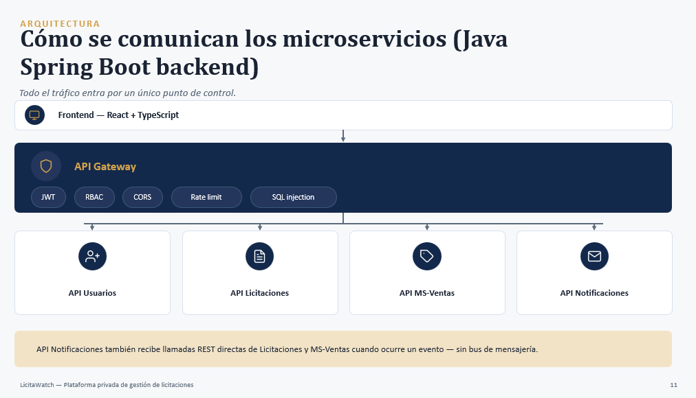
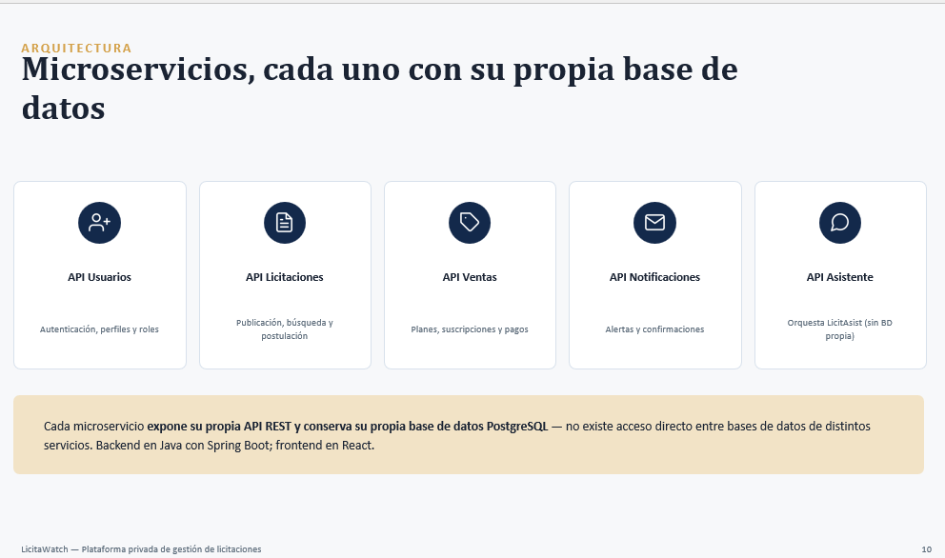
Data model screenshot | Data model that will define the system database | It is agreed to insert the project’s defined data model | Shows significant progress

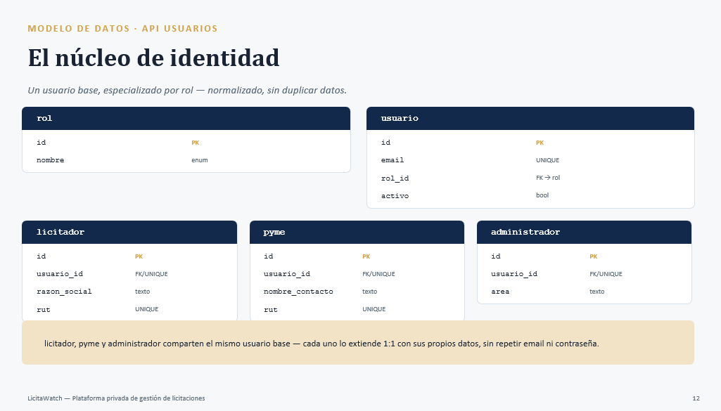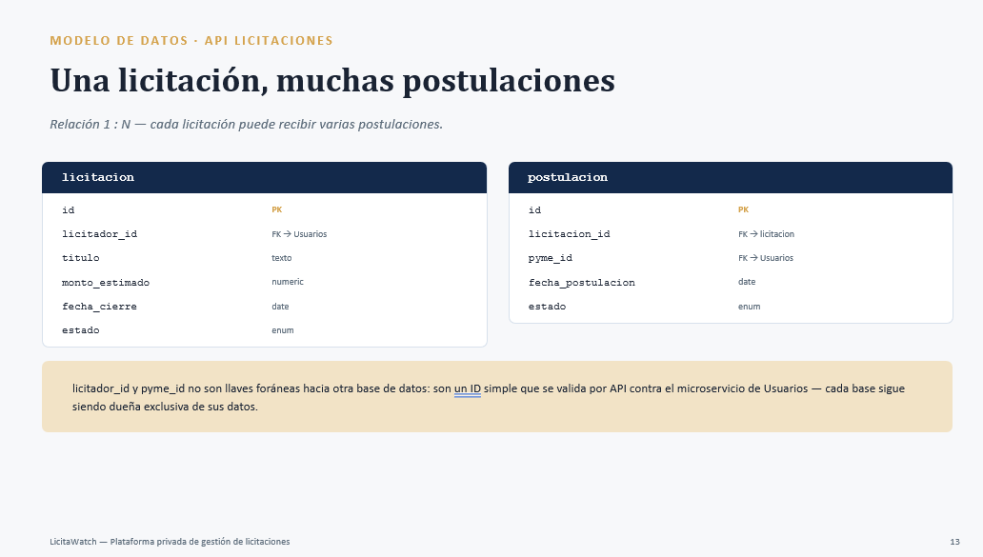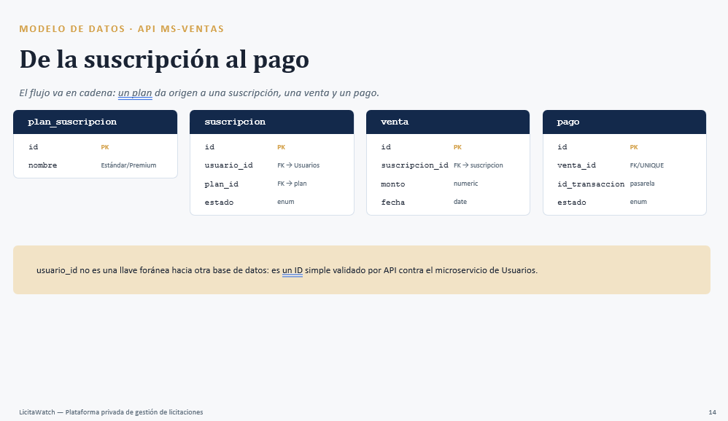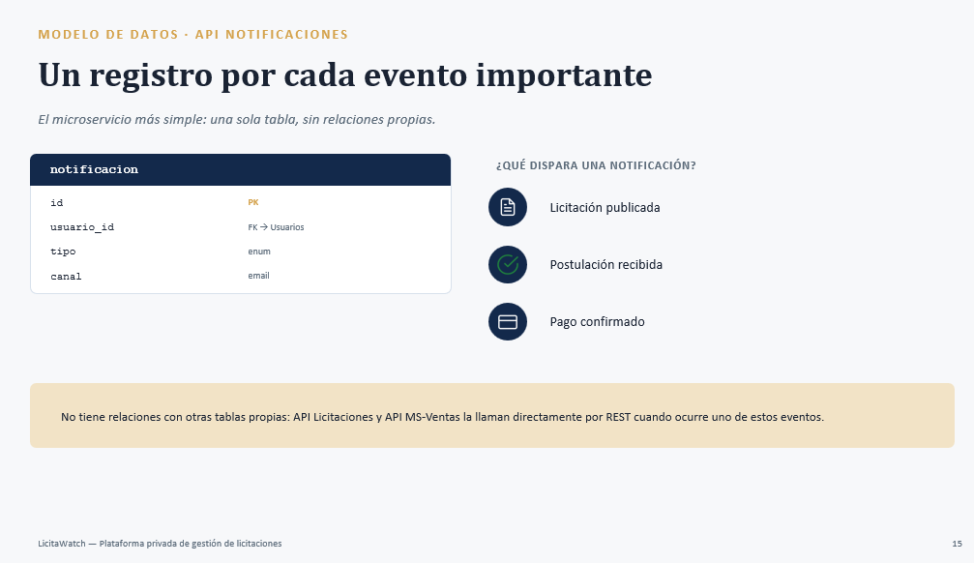
Front-end screenshot | Development front end | It is agreed to insert an image of the project page front end | Shows significant progress
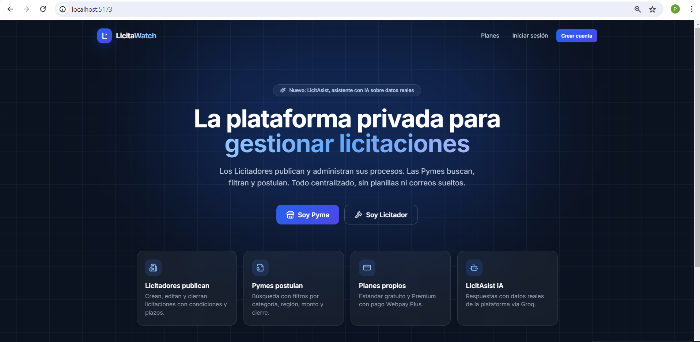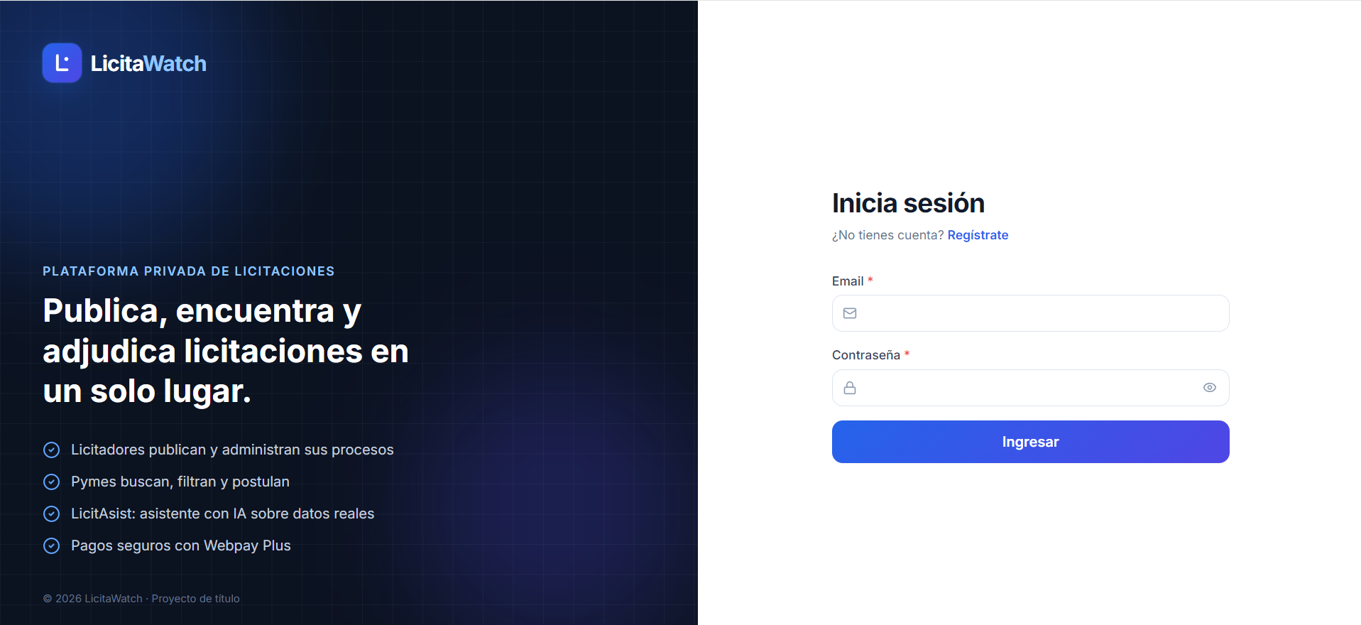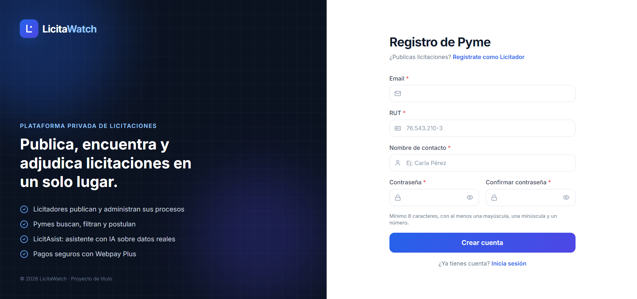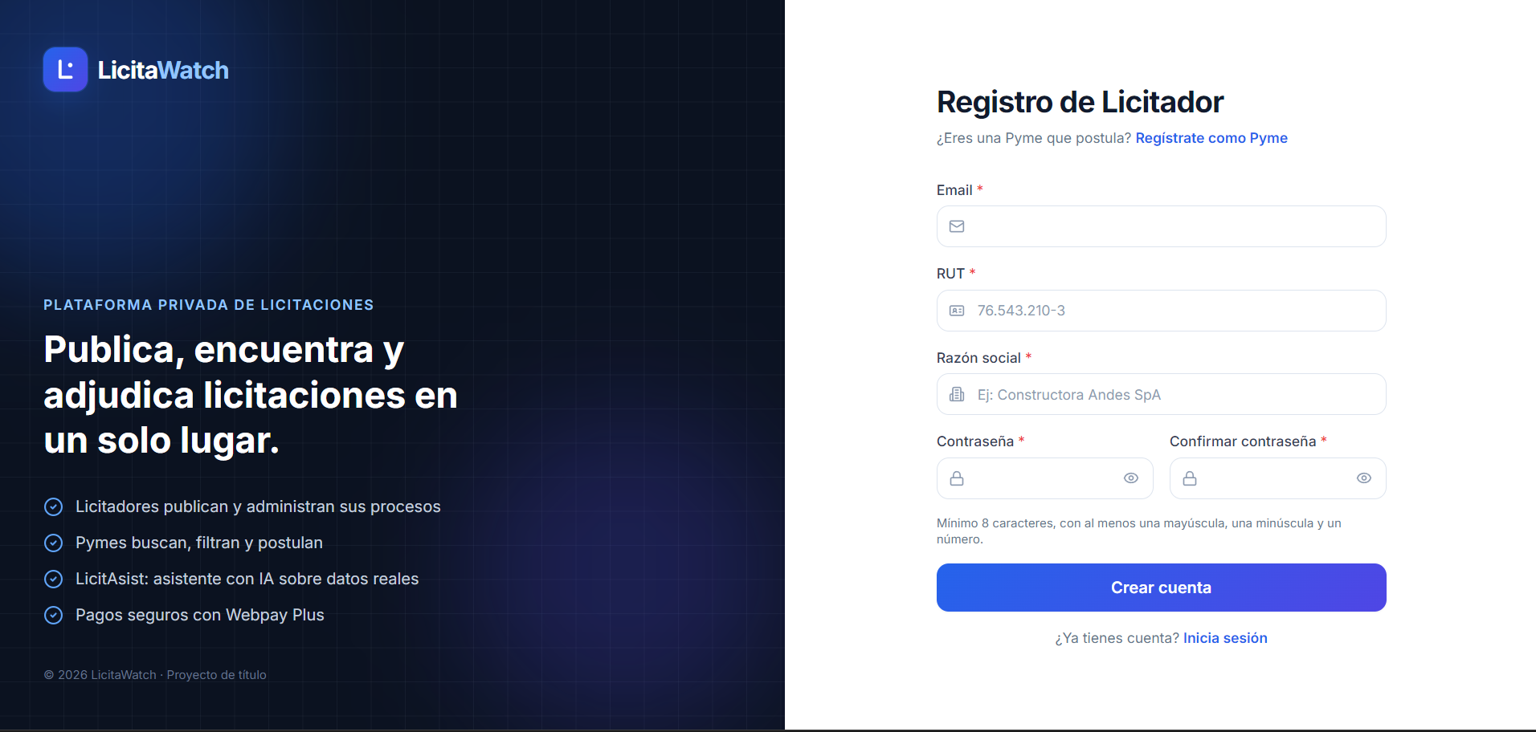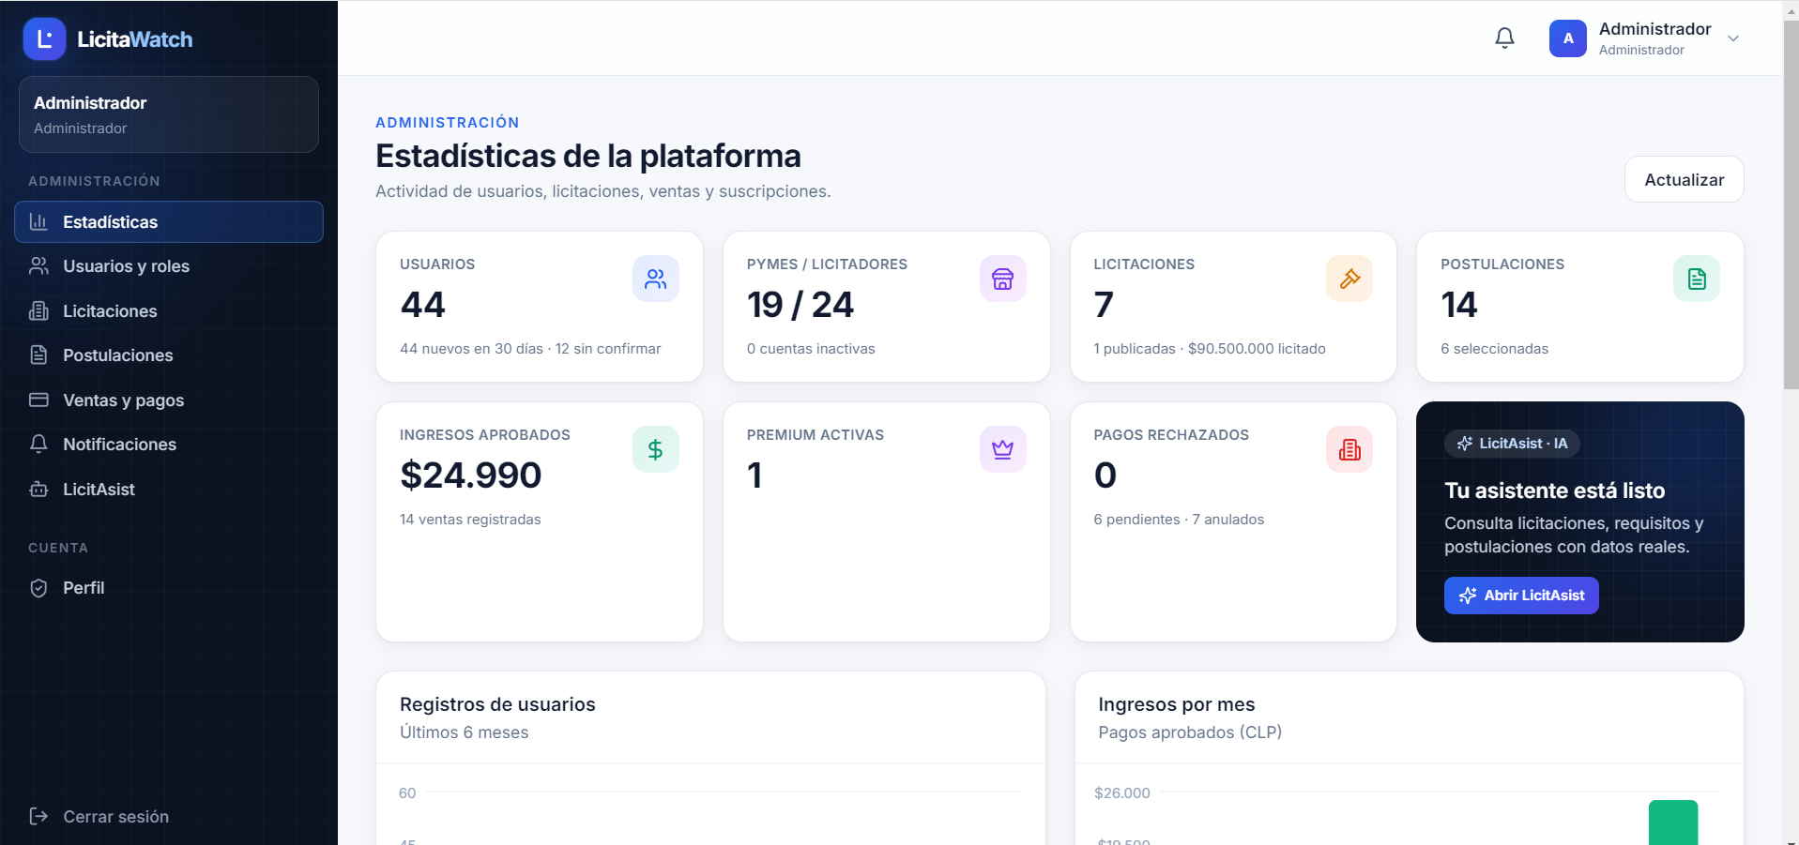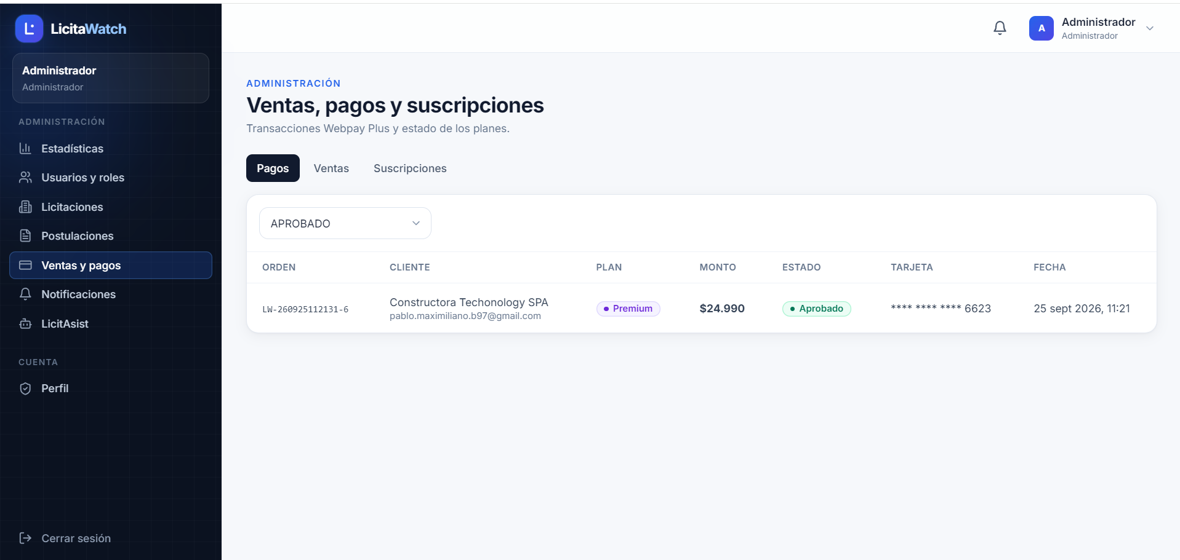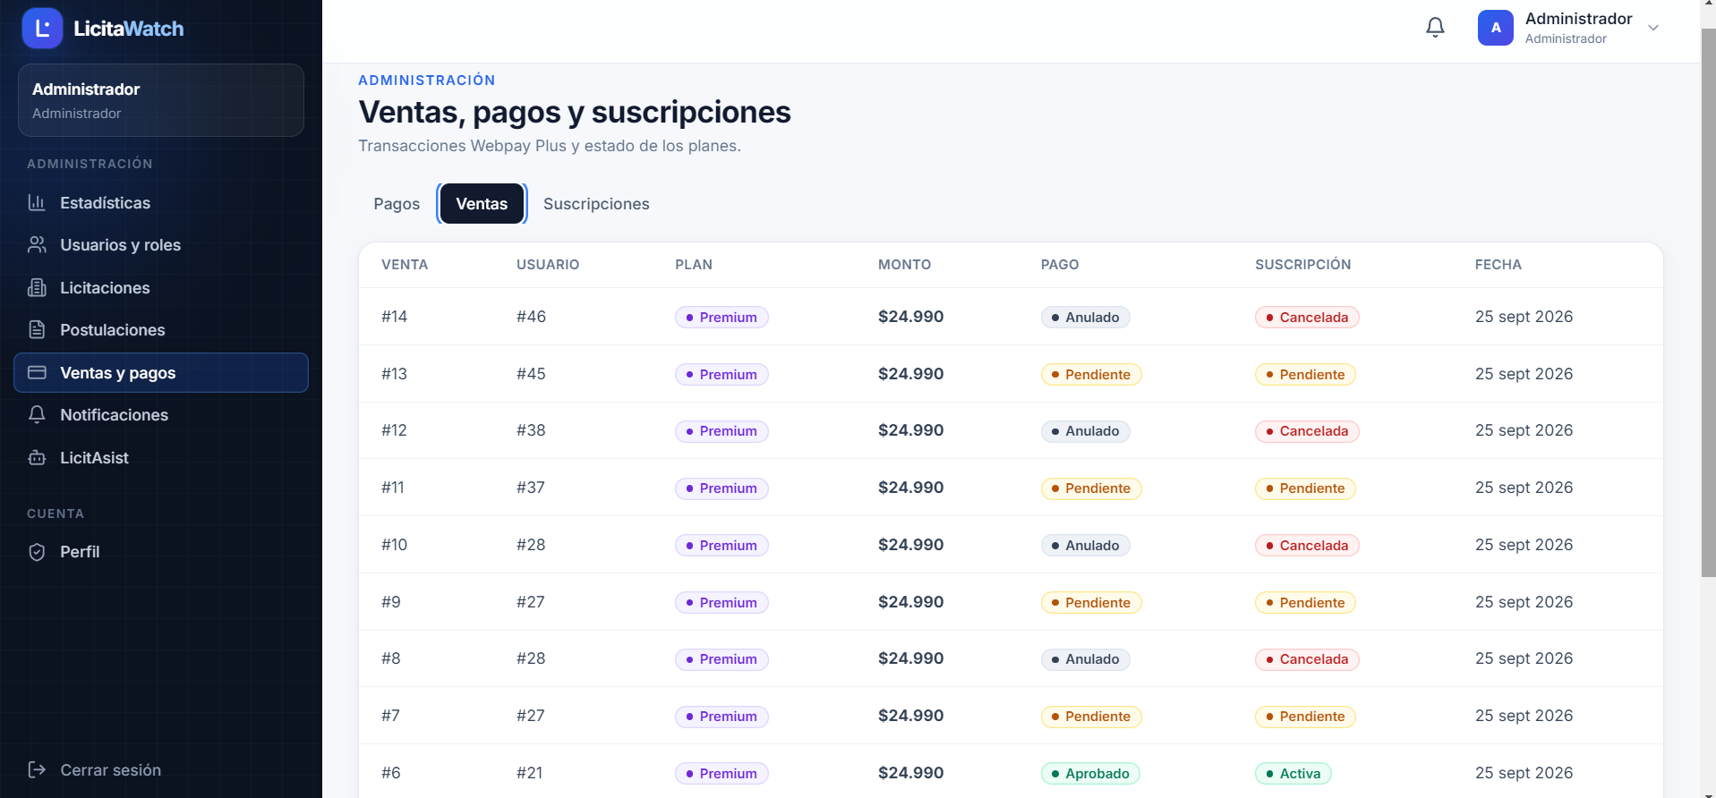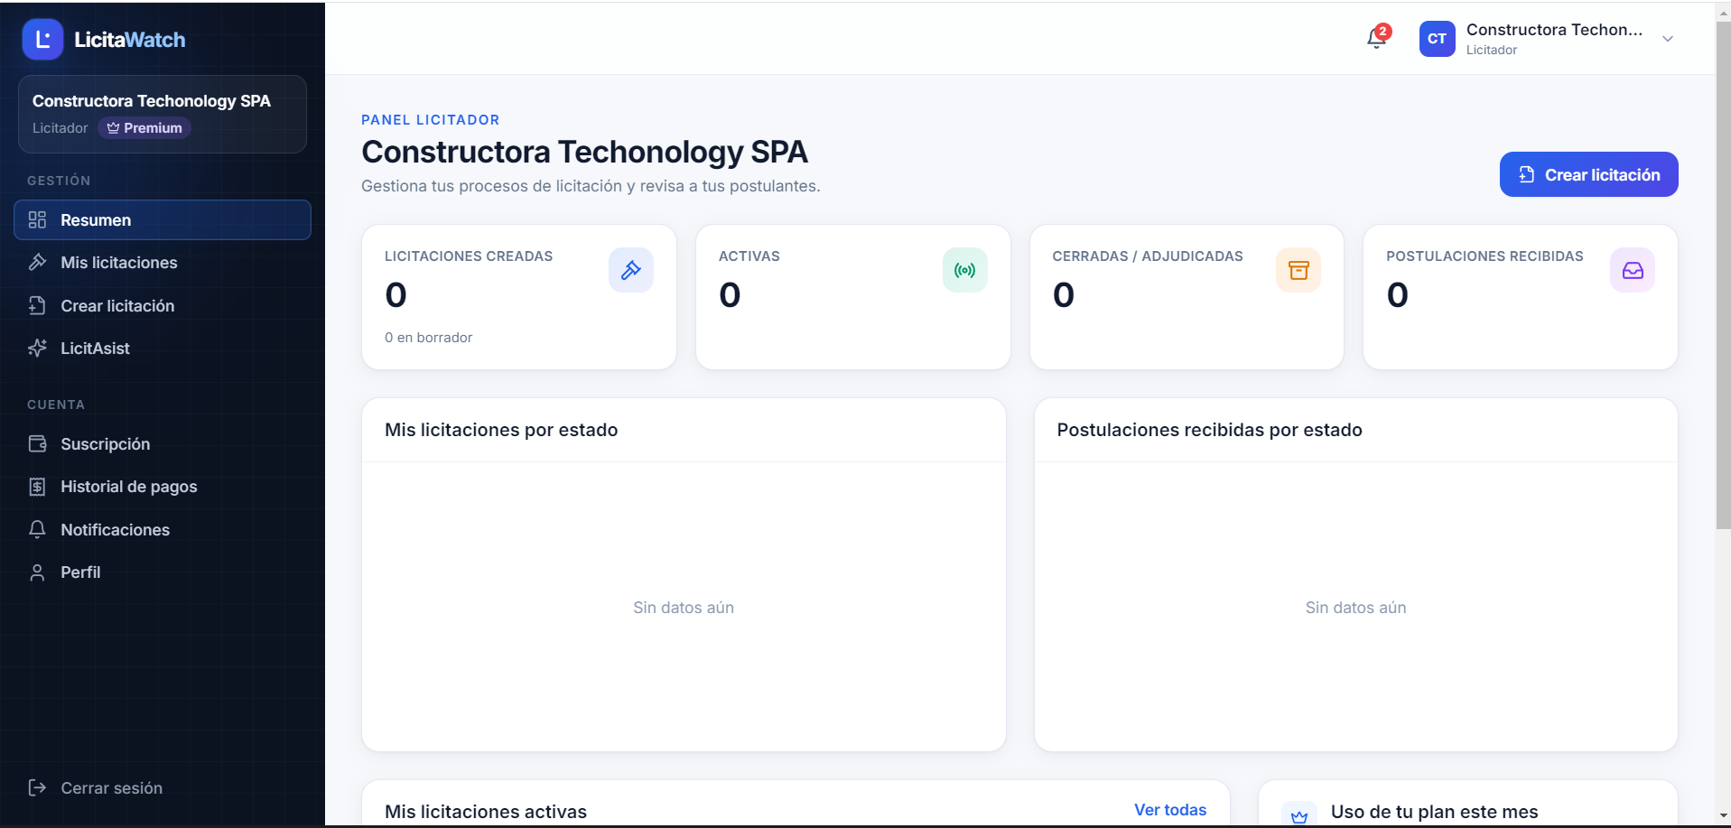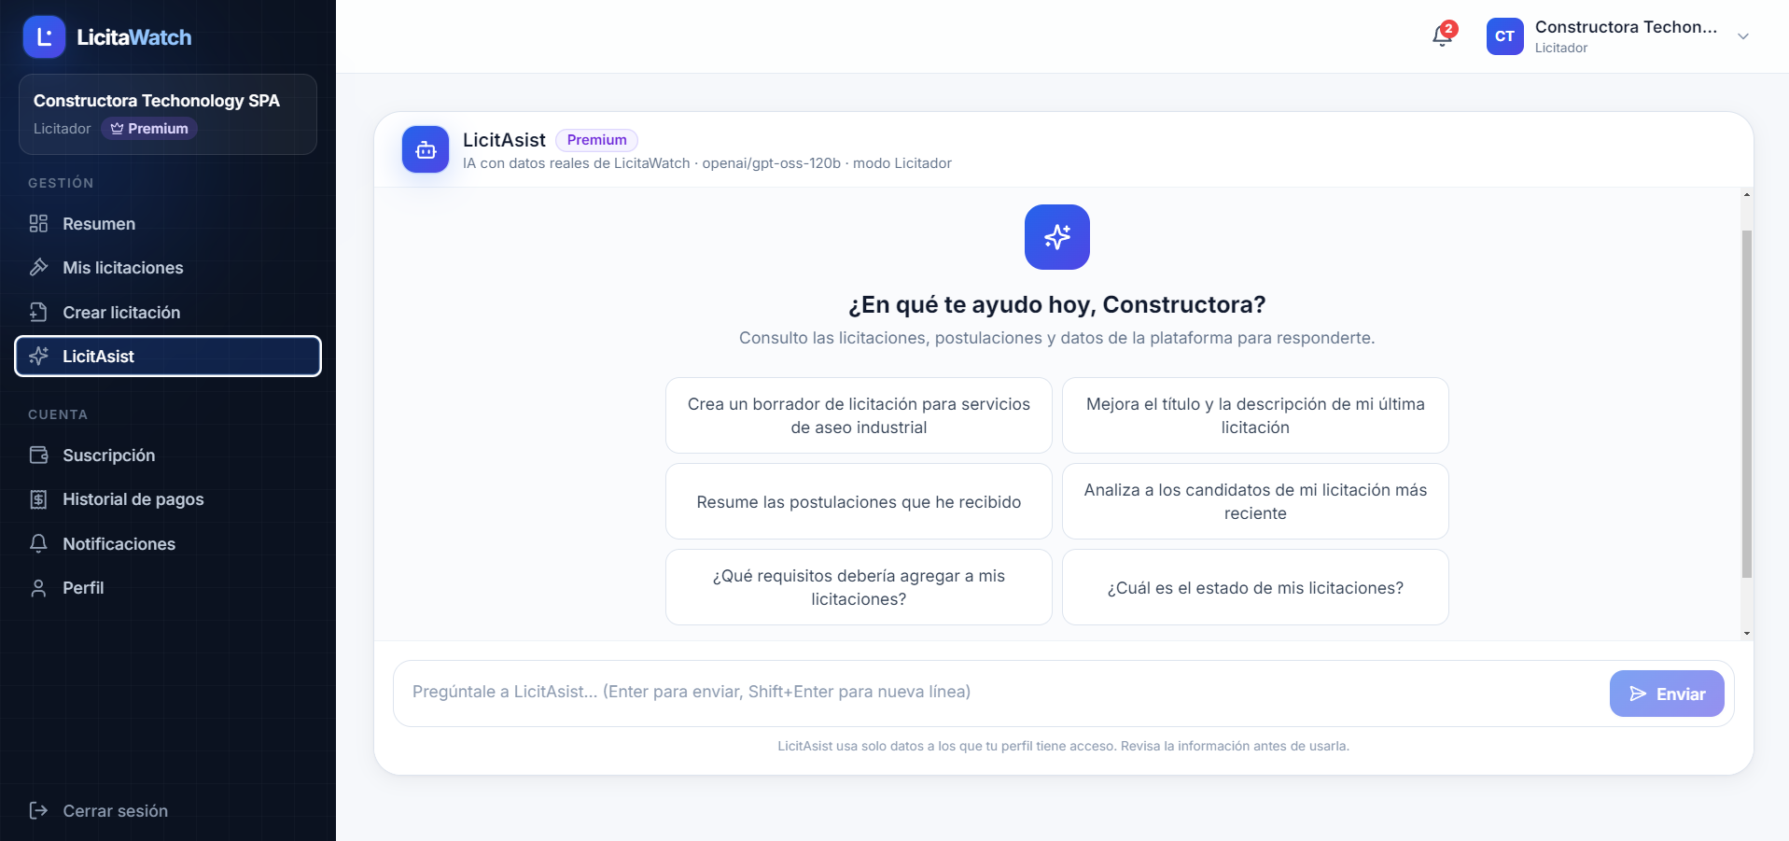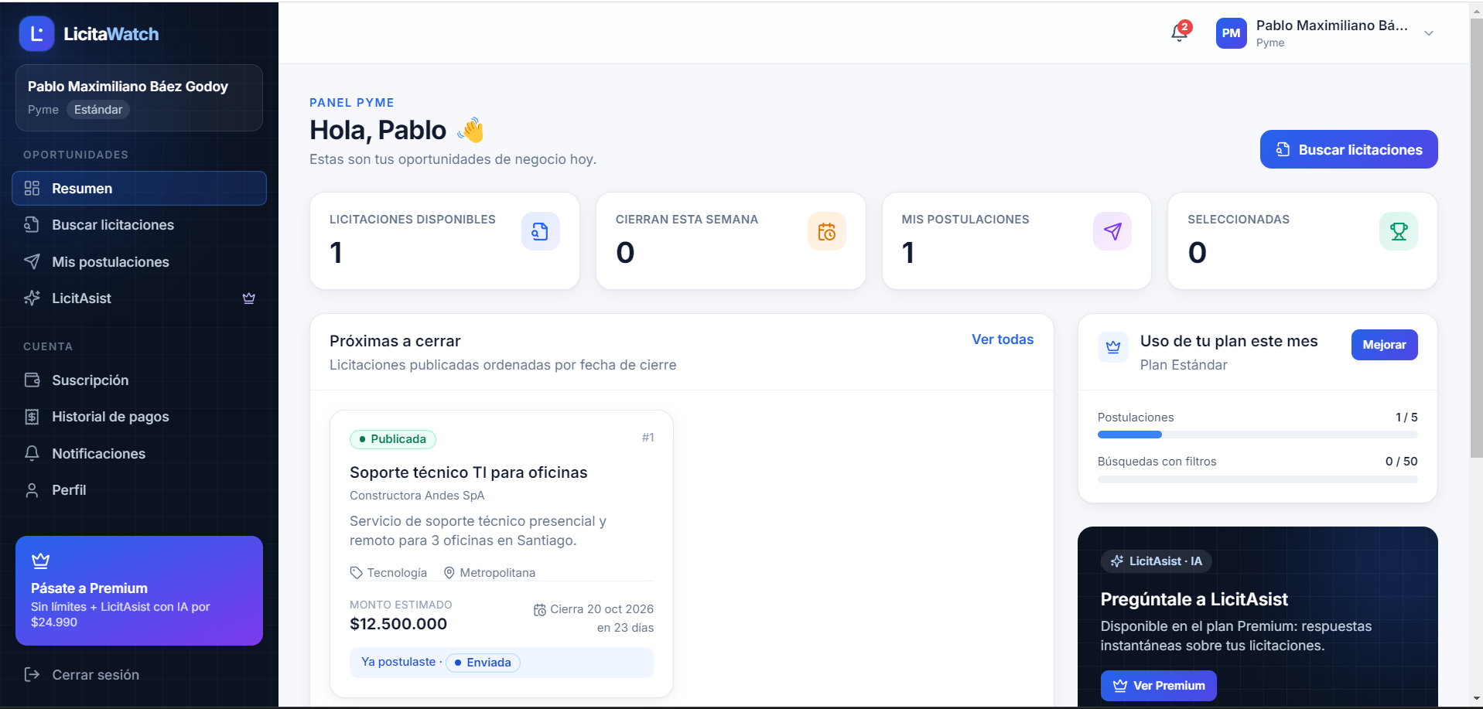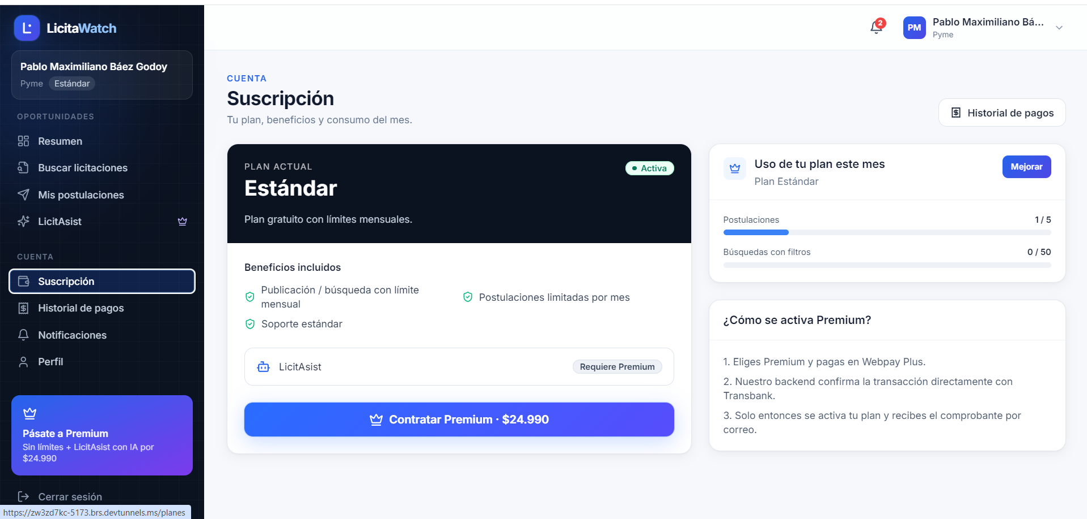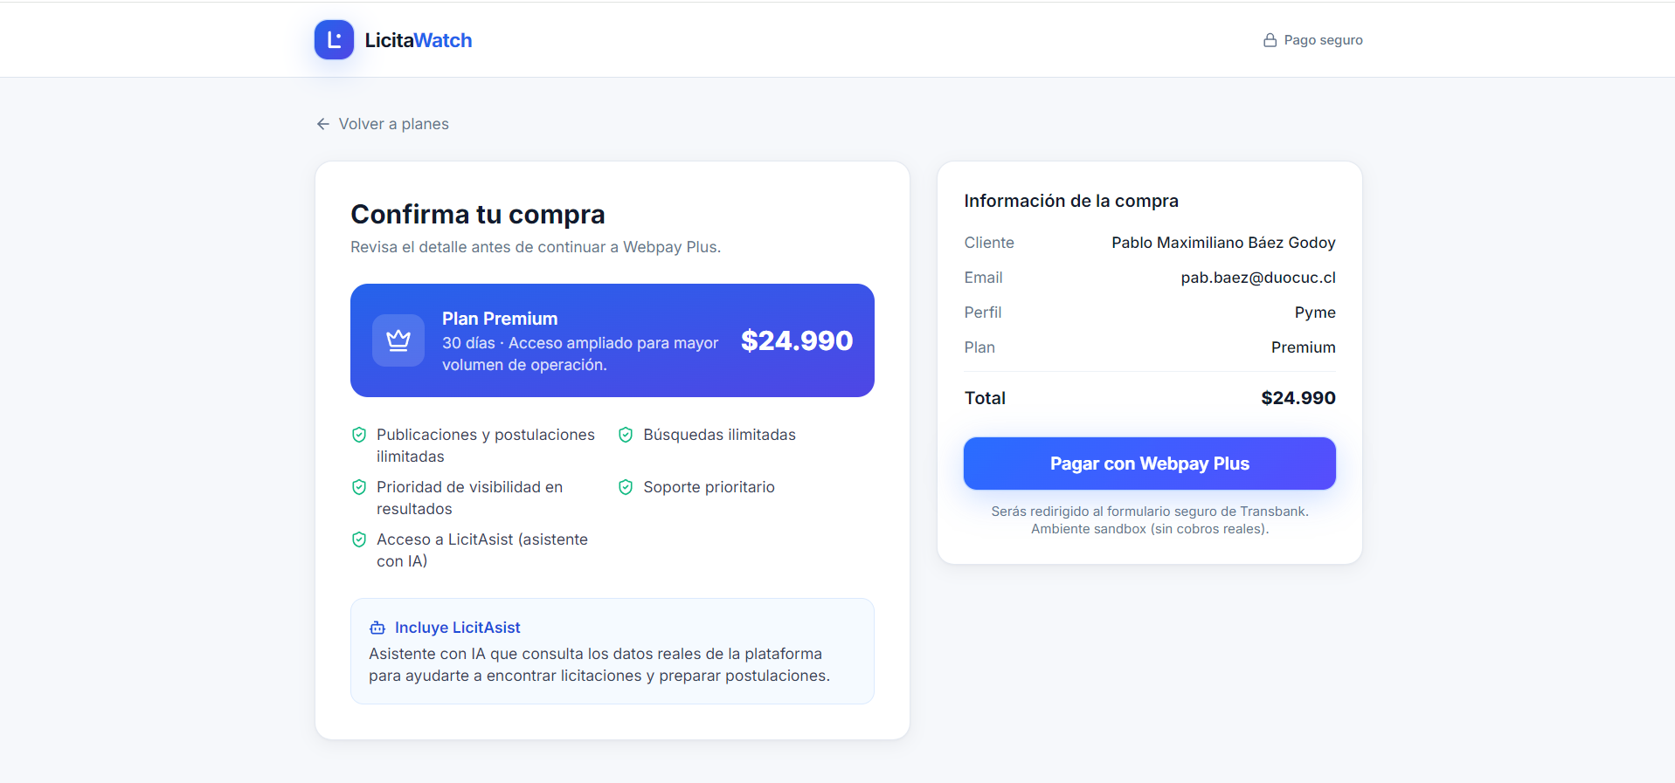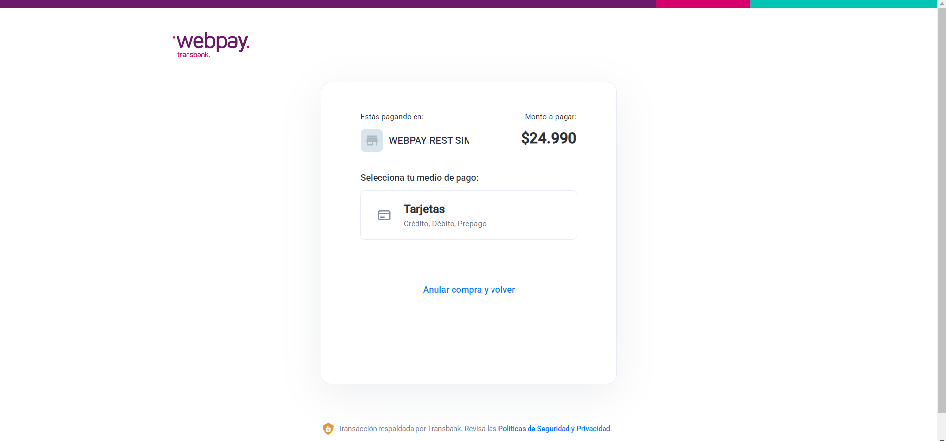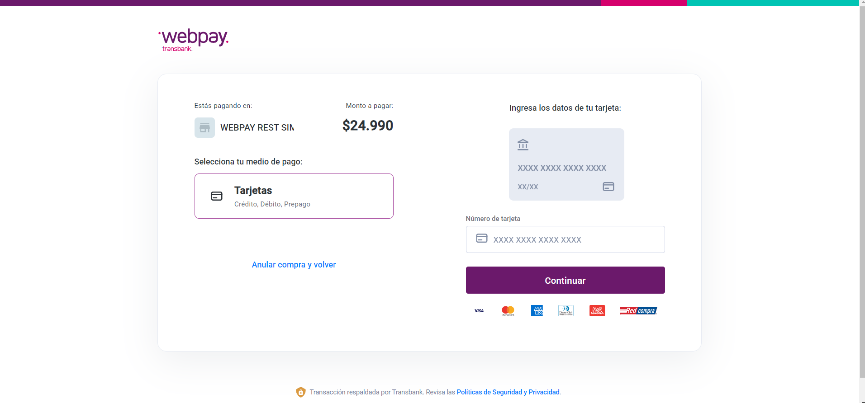
7. Work Plan
In the following table, define the planning of your APT Project according to the requirements.

APT Project Work Plan
Competency or competency units | Name of Activities/Tasks | Description of Activities/Tasks | Resources | Activity duration | Person(s) responsible | Observations
2, 4, 7, 16 | Sprint 0 – Initial analysis, design, and architecture | Gather and analyze the project’s functional and non-functional requirements. Define the MVP scope, user stories, and acceptance criteria for the Tenderer, SME, and Administrator profiles. Design the microservices architecture, data model, and PostgreSQL databases for each service. Configure repositories, development environments, Front End and Back End, and define communication (REST) and security (JWT/RBAC) guidelines. | Documentation, Product Backlog, diagramming tools, Git, React, TypeScript, Spring Boot, PostgreSQL, Docker. | 2 weeks | Pablo, Gonzalo, and Daniel | A proper definition of scope and API contracts reduces later changes; the Backlog may be adjusted during the project according to Scrum.
3, 5, 13, 15 | Sprint 1 – Users and Registration | Develop registration and login for the SME and Tenderer profiles. Implement the base user table and its 1:1 extensions by role, JWT authentication, and role-based authorization (RBAC). Integrate the Front End, Users API, and database. | React, TypeScript, Spring Boot, PostgreSQL, JWT, RBAC, Postman. | 2 weeks | Pablo, Gonzalo, and Daniel | Validate authentication, permissions, and restrictions corresponding to each profile; this foundation is used by the rest of the project.
3, 4, 5, 13, 14 | Sprint 2 – Tenders | Develop the publication, editing, and closing of tenders by the Tenderer, together with tender search and filtering by the SME. Implement the Tenders API, its data model, and associated persistence. | React, TypeScript, Spring Boot, PostgreSQL, API REST, Postman. | 2 weeks | Pablo, Gonzalo, and Daniel | Validate business rules, required data, and tender statuses (published, closed).
3, 4, 5, 13, 14 | Sprint 3 – Applications and Selections | Develop the SME application to a published tender and the review and selection of applications by the Tenderer. Integrate the Front End, Back End, and database for the complete application cycle. | React, TypeScript, Spring Boot, PostgreSQL, API REST, Postman. | 2 weeks | Pablo, Gonzalo, and Daniel | The relationship between SME, tender, and application must be validated, along with the corresponding statuses.
3, 5, 13, 14, 16 | Sprint 4 – Administrator Module and Application Status | Develop Administrator account enablement and login, as well as the administration panel (management of users, tenders, and sales). Implement application status tracking for the SME. | React, TypeScript, Spring Boot, PostgreSQL, API REST, Postman. | 2 weeks | Pablo, Gonzalo, and Daniel | This is the project’s highest-workload sprint; the scope of the Administrator panel must be carefully controlled so as not to compromise the rest of the sprint.
3, 6, 12, 13, 14 | Sprint 5 – External Payment Gateway | Develop MS-Sales to manage Standard and Premium plans, subscriptions, and sales. Integrate an external payment gateway to charge subscriptions, handling both successful and declined payment cases. | Spring Boot, PostgreSQL, React, TypeScript, REST API, payment gateway (test environment), Postman. | 2 weeks | Pablo, Gonzalo, and Daniel | There is a dependency on an external service; a test environment (sandbox) will be used for financial integrations.
6, 12, 14, 15 | Sprint 6 – LicitAsist (AI) + Notifications | Integrate the LicitAsist conversational assistant through the Groq API and develop the automatic notification system (tender published, application received, payment confirmed). Execute functional, integration, and security tests on the Tenderer, SME, and Administrator flows, and record and correct detected issues. | AI API (Groq), Spring Boot, React, PostgreSQL, Postman, Docker, Git, technical documentation. | 2 weeks | Pablo, Gonzalo, and Daniel | There is a dependency on the free tier of the AI API; as this is the final sprint, overall integration and stabilization must be prioritized before closure.

8. Gantt Chart (Appendix 1)
Choose a Gantt Chart format that suits you and organize the activities planned in the previous section, considering the period assigned for the development of your APT Project. You must maintain the timing of the academic period throughout the development of the three phases included in the Degree Portfolio course.
